Addysg Oedolion Cymru | Adult Learning Wales **Safeguarding Officers**

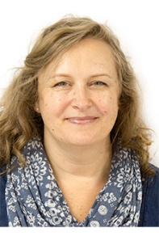

**Youth Community and Play Work (YCPW) Manager**  
Rachel Burton  
02920 382431 / 07960 858835

**Head of Learner Services and Resources**

**(Designated Safeguarding Lead)**  
Cath Hicks   
02921 678714 / 07931 204613

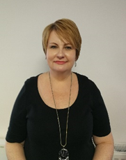

**Regional Manager South West and Mid Wales**Karen Fisher   
 01686 610270/ 01792 467791/ 07432 881123

**Regional Manager North Wales**Sarah O’Connell Jones   
 01248 363945/ 07930 867908

**Regional Manager South East and Central Wales**  
Jayne Ireland   
 02921 678 725 / 07787 423632