How to generate a QR code

Step 1
Go to the website:

http://qrcode.kaywa.com/

Step 2
When the QR code is “read”, it will link to some content of your choosing.
Select the type of content you want to put in. In my case I want to use text so I click here.

Step 3
Type or copy and paste your text into the “Free text” block here

Step 4
Click “Generate”

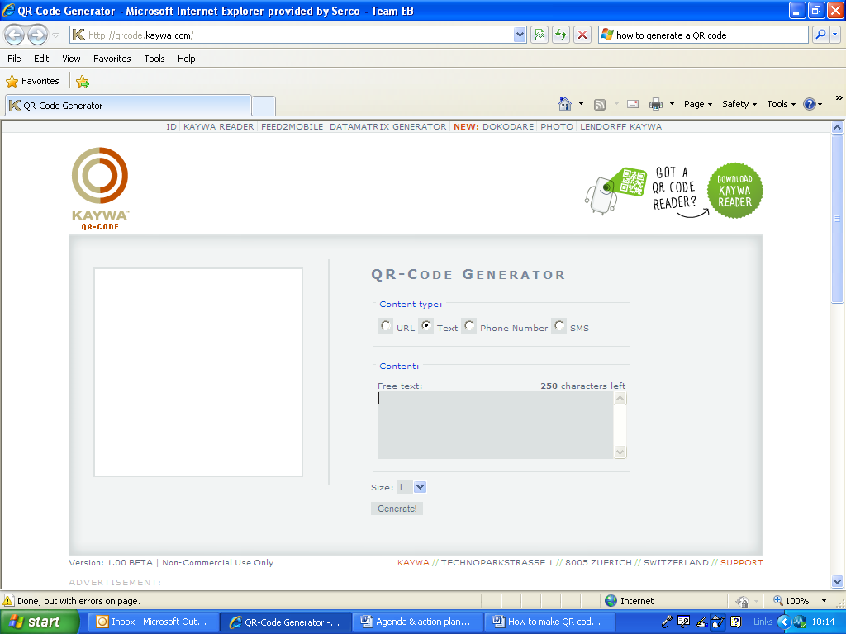

Step 5
Now save this to a file (just as you would normally save a document).

Step 6
Once it’s saved, copy it from your saved documents onto the document you are going to print out.

Finally, test your QR code before you print out lots of sheets - the quality of the printing matters, as does the size of the code itself.

