Addysg Oedolion Cymru | Adult Learning Wales Safeguarding Officers
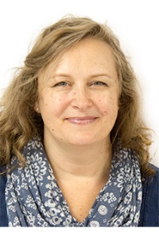


Youth Community and Play Work (YCPW) Manager
Rachel Burton
02920 382431 / 07960 858835

Head of Learner Services and Resources
(Designated Safeguarding Lead)
Cath Hicks
02921 678714 / 07931 204613



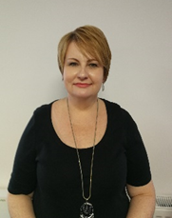

Regional Manager South West and Mid Wales
Karen Fisher
01686 610270/ 01792 467791/ 07432 881123

Regional Manager North Wales
Sarah O’Connell Jones
01248 363945/ 07930 867908
Regional Manager South East and Central Wales
Jayne Ireland
02921 678 725 / 07787 423632

